Media contact
Joanna Krzemińska
asia@aspire.org.pl
+48 536 333 066

Old and New Kraków unite to support Ukrainian Teens

Two of Kraków’s most respected institutions - representing the old and the new - have joined forces to offer support to Ukrainian teenagers displaced by war in Ukraine.
Akademia Ignatianum - the university of the Jesuit order in Kraków, whose roots stretch back to the 16th century - has teamed up with ASPIRE - the representative body of Kraków’s IT and Business Services Companies and a key driver in Kraków’s emergence in recent years as a business hub.
Together the two organisations are opening a network of Education Hubs aimed at providing safe spaces for young Ukrainians to come together to socialise, carry on their education and get support.
ASPIRE is leveraging the resources of ASPIRE member companies to provide safe, modern, social spaces, as well as lunch and snacks. Ignatianum is overseeing a rich programme of integration activities. Together the two organisations are funding teachers.

Key points:
- ASPIRE - the representative body of Kraków’s IT and Business Services Companies - in cooperation with the Ignatianum Academy in Kraków, has launched an initiative to support Ukrainian teenagers.
- The ASPIRE Education Hub leverages the resources of ASPIRE members to provide safe, modern, social spaces for teenagers to come together, to socialise, carry on their education and receive emotional support.
- The Ignatianum Academy is overseeing a rich programme of integration activities, also with the support of young employees working in participating companies.
- Following a successful pilot for 25 children which has been running since the end of May, 4 new hubs are opening in the next two weeks with plans for more to follow.
- The Hubs which are located in company offices are are open Monday to Friday from 9 am till 4 pm
- The initiative aims to support a minimum of 200 Ukrainian children. Already in the next two weeks the figure will be over 100.
- In August, the initiative has gained the support of UNICEF.

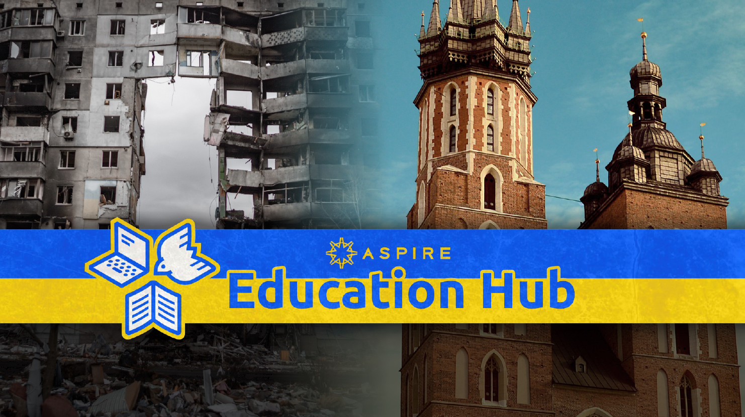

The ASPIRE Education Hub is an initiative developed by ASPIRE - the representative body of the IT and Business Services sector in Kraków - to support Ukrainian teenagers displaced by war.
ASPIRE estimates that as many as 25,000 teenage Ukrainian refugees are living in Kraków with their mothers, aunts and siblings.
The aim of the initiative is to utilise offices of ASPIRE member companies to create safe and well-equipped spaces for teenage refugees to come together, to socialise and participate in a wide range of educational and fun activities.
Kraków is Europe’s hub for Tech and Business Services and companies in the city lease well over 1 million square meters of modern, state of the art office space in the City. The introduction of work from home during the COVID pandemic mean that less space is currently being utilised than before and although employees are returning to the office, occupancy is unlikely to return to pre-pandemic levels.
To support the implementation of the project, ASPIRE has partnered with one of Krakow's most respected, recognised and renowned institutions, the Ignatianum Academy. Ignatianum runs a foundation which is coordinating the programme of activities.
ASPIRE members provide facilities, as well as lunch and snacks. Ignatianum and ASPIRE jointly fund teachers and other sources of private and public funding are being sought.
The initiative kicked off at the end of May with a consultation meeting with the Ukrainian community attended by over 100 mothers and children. As a result, 70 teenagers signed up for the Hub.
The first Hub catering for 25 children launched one week later on 30 May at the Aon Centre in Enterprise Park in Zabłocie. This has provided a proof of concept and a source of reference for other companies now joining the initiative.
Last week (25 July) two more locations opened at the ABB Corporate Technical Centre based in Pałac Pugetów on ul. Starowiślna and the ABB GBS Centre in the Axis Building at Przy Rondzie.
This week (1 August), two more locations are opening at the AMS Centre in the Bonarka 4 Business complex adjacent to the the Bonarka Shopping Centre and the Grand Parade office at Kotlarska 11.
The original focus of the programme was to provide children with the opportunity to continue online studies organised by the Ukrainian Ministry of Education, but currently the greater need seems to be for integration activities and the opportunity to socialise. As well as language lessons in Polish, English, Spanish and French, activities have included yoga, art, performance, chess and computing, as well as meetings with Japanese, American and Polish children.
By the end of the year it is anticipated the Education Hub will cater to a minimum 200 children with more hubs opening in other centres.
Already the initiative is attracting the attention of international agencies with the prospect that the programme could be replicated in other cities in Poland and across Europe. Already UNICEF has become a partner in the programme from August.
Although Polish schools are, of course, open to the refugees, there is evidence that the language barrier and differences in the educational systems of the two countries, has been stressful for Ukrainian children, leading also to truancy. The local education authorities are seeking to address this issue with specialist Ukrainian schools being muted.

Quotes:

Speaking about the initiative Andrew Hallam, General Secretary of ASPIRE, said:

Why we are helping:
The tech and business services sector is a big part of Kraków life and it is our duty to help. Companies and their employees have been providing support in different ways from the moment the war began. However, we felt we could provide a structured approach uniting companies across the sector so as to achieve greater focus and scale to these efforts.
One resource we have is modern office space and so we looked at how best we could leverage this across the network. Another resource is young, talented people working in our centres who as the programme grows we anticipate will help enrich the programme sharing their passions.

On Akademia Ignatianum:
We are very happy that we could team up with Akademia and Fundacja Ignatianum. Without their enthusiasm and support this could not have happened. They are a 500 year old NGO embedded in Kraków and I think this makes all the difference. They understand the meaning of the things that make Kraków tick, its genius loci - Kraków’s spirit of openness, tolerance, generosity and intellectual and mercantile curiosity.

On companies that are hosting hubs:
This could not happen without the good will of companies, but more than that individuals in those companies that make things happen. We are especially grateful to John Lyons, the head of the Aon Centre in Kraków, and his team. It is not always easy for corporations to make quick decisions to support projects like this, but John showed true leadership in making it happen, not least in showing it in action for others to see. We are, of course, also grateful to the other companies and individuals that have so far stepped forward from ABB, AMS and Grand Parade and others who are now considering, as well as companies such as the law firm CDZ that have been providing pro bono legal support.

On whether hubs are necessary if Polish schools are open to Ukrainian teenagers:
We are building a structure to support teenagers. The essential ingredients are safe spaces, facilitated learning and food. Within that structure we can pivot according to need. Originally we anticipated spaces for online learning; currently we are providing something more akin to a Summer School; in the future, possibly after-school clubs - something like the Polish schools which are so popular among the Polish community in other countries where Poles have settled.

On the future of the programme:
I think we are setting an example. Our industry employs over 100,000 people in Kraków so we believe we can provide a scaleable solution. More than that we hope to bring the initiative to the attention of international agencies to scale and spread the initiative.
You only have to look at the change in those attending the Hub to see what its all about! If we only help one teenager through the trauma it would be worth it.

Stanisław Alwasiak, Coordinator of the programme for Fundacja Ignatianum said:
As a foundation we have considerable experience working with refugees and especially helping them to integrate and feel supported. It is traumatic to be displaced especially at such an age. It. Is really exciting to be able to partner on this project with ASPIRE. We can see how the children are transformed by the experience. It really works.

John Lyons, Centre Head of Aon, which opened the first hub, said:
We got together as a team and discussed ways in which we could provide support to refugees from Ukraine.
Thousands of teenagers have been displaced from their homes, families, schools and friends. This is very stressful for them.

Through the ASPIRE Education Hub we have provided facilities for the Ignatianum Foundation to deliver an educational programme for displaced Ukrainian teenagers.

We were happy to be the “guinea pig” to set up, operate and prove the concept for the first group. After two months of operation we are very pleased with the programme. It has run very smoothly.

We are happy to share our experiences in setting up the program with Ignatianum with all companies interested in participating or supporting in whatever way they can.

It is great to see more companies coming on board to support the programme. The more participation we have, the more sustainable we can make the programme.

Przemysław Zakrzewski, Head of the ABB Corporate Technical Centre, said:
We wanted to do something that could grow and have impact, linking all organisation that want to join forces following ESG criteria and principles on environment, sustainability and good governance. This co-ordinated effort through ASPIRE provides focus and scale, which is needed, because in spite of all good efforts people have made the past few months energy levels can fall.
I think of this project as being like a start-up. We are putting together a structure which can attract support, get input and ideas from others, at the same time remaining agile to pivot to meet whatever the need will be.

About ASPIRE
ASPIRE is the representative body of the tech and business services companies in Kraków and is widely credited with helping Kraków to become Europe’s leading hub for the sector. The Association has 160 member companies, including companies such as Aon, ABB, AMS and Grand Parade who are hosting Education Hubs at their facilities.

About the Ignatianum Foundation
The Ignatianum Foundation runs outreach and charity projects of the Ignatianum Academy in Kraków. The foundation supports worse-off and outstanding students but also involves Ignatianum students and faculty in voluntary work for migrants, children, senior citizens and Polish minorities in Eastern Europe.
A flagship Ignatianum Foundation project is “Kredkobranie/Crayonpicking”. In the 2021 edition of the programme volunteers in 500 schools and kindergartens collected school supplies worth ca PLN 1 million and delivered them to Polish schools abroad.
The Foundation team has a long track record of Ukrainian migrants support and many Education Hub volunteers are alumni of earlier Ignatianum programmes.

Partners:
Education Hub hosts: Aon, ABB, AMS, Grand Parade, Lufthansa
Supporting companies: CDZ, Select, PwC, Qurate Group
Supporting organisations: UNICEF

Donations

Donations are essential to support the operation of the hubs.
Here are examples of how even the smallest amount can significantly support the project:

๏ 25 PLN pays for lunch, snacks and drinks for one student for one day.
๏ 500 PLN pays for lunch, snacks and drinks for one student for one month.
๏ 6,500 PLN pays for a teacher for one hub for one month.
๏ £12,500 pays for lunch, snacks and drinks for a class of 25 students for one month.

Payments can be made to the following accounts:

ASPIRE Education Hub
PL 63 1090 2590 0000 0001 4312 3624
Ignatianum Foundation
PLN: PL93 1600 1462 1082 1723 8000 0009

Contact

Joanna Krzemińska
asia@aspire.org.pl
+48 536 333 066
www.educationhub.pl

